**Visualization of the data we got into graphs:**

**Comparison of the various algorithms we used:**

We have used 80% 20% ratio of our train data for testing, when we tested on 20% of the data the comparison of algorithms is as below:

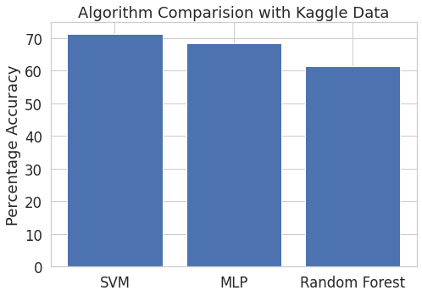

**Testing with Twitter data:**

**Example tweets we extracted from twitter: #olympics**

Output from the code we ran: (cleaned tweets after removing all the URL’s)

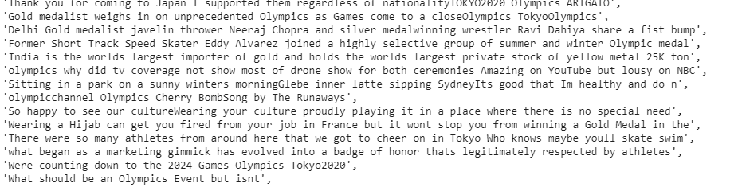

**Comparison of results on various algorithms for #olympics:**

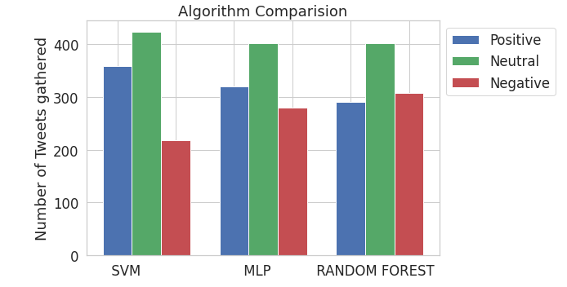

**Examples of tweets from twitter for #angry :**

**Output from our code for #angry**

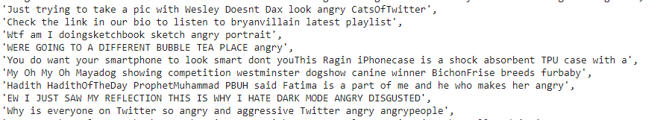

**Comparison of results on various algorithms for #angry:**

